Huntington Beach State Park

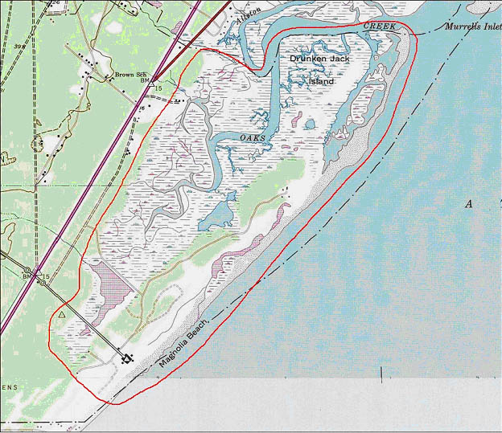

Description: Huntington Beach State Park is located in Georgetown County and managed by the SC Department of Parks, Recreation and Tourism. The park includes 1,060 acres of salt marsh and tidal waters, 750 acres of woodlands, 90 acres of freshwater lagoon, 400 acres of maritime shrub thicket and 200 acres of sandy beach and dunes. A causeway from the mainland to the beach separates saltwater mudflats from freshwater impoundments. There are two camping areas, an education center, two nature trails and numerous boardwalks extending out into the salt marsh and freshwater lagoon for wildlife viewing.

Shorebird areas include the rock jetty on the north end, the ocean beach from the north parking lot to the jetty, including a tidal-brackish pond, the salt marsh extending from the causeway to the education center and freshwater Mullet Pond on the south side of the causeway. All areas are accessible by foot. They are also subject to frequent disturbance.

According to Jack Peachey, Huntington Beach is very important as a shorebird wintering site, supporting hundreds of Dunlin, Semipalmated Plover and Short-billed Dowitcher. Smaller numbers of BBPL, SAND, REKN, WESA, GRYE, and PIPL also occur here in winter.

A major restoration project is planned for the Spring, 2005. Sandpiper Pond, which in the past hosted many migrating shorebirds, no longer does so in great number. An invasion of Phragmites ensued when Hurricane Hugo and other Atlantic storms choked the pond of its salt water intake. To discourage the overgrowth, a channel will be opened allowing salt water to reach Sandpiper Pond. Other activities will be undertaken to remove the vegetation that remains.

The most numerous species from ISS maximum count data are: BBPL (270), WIPL (150), SEPL (650), PIPL (30), AMOY (75), GRYE (35), LEYE (21), SPSA (20), WILL (210), RUTU (375), REKN (500), SAND (750), SESA (300), LESA (62), SBDO (710) and DUNL (1,600).

Survey Method: Ground surveys at all areas. The jetty and beach is best at mid tide to low tide. The salt marsh is best at nearly low tide, either incoming or outgoing. The freshwater pond is worth surveying if water levels are low, leaving exposed edges.

Selection Bias: *

Measurement error: Phragmites overgrowth at Sandpiper Pond may lead to measurement error if shorebirds are obscured from view.

Measurement bias: The restoration and removal of invasive vegetation at Sandpiper Pond may result in measurement bias. This could be a factor if there is a long-term trend in the number of birds detected and the number of birds present at Sandpiper Pond.

Pilot Studies: None needed.

Local Contacts: Jack Peachey, Wacamaw Audubon Society.

